Outstanding Long Service to the Community.

Outstanding Achievement. Overcoming Adversity.

Youth Award.

The four categories are:

Address:

Nominee:

20233

C I V I C

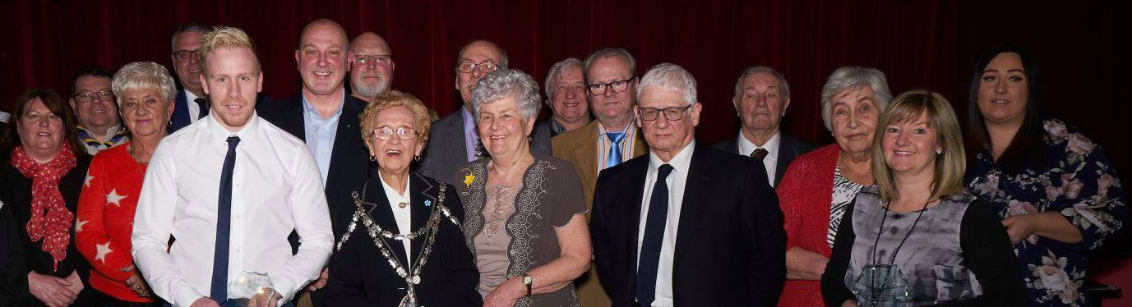

BLAENAVON TOWN COUNCIL

Nomination for Civic Award 2023

Please specify which type of award the nomination is for and give a detailed overview of your nomination.

.

### 

### 

Nomination forms for long service awards to be completed by the secretary of relevant organisation.

Please continue overleaf.

1.

2.

3.

4.

A W A R D S

2023



C I V I C

A W A R D S

Please return completed nomination form to:

Closing date: Midday 11th of October 2023

Mr Kevin Warren,

Chief Officer to the Council

101 High Street

Blaenavon

Torfaen

NP4 9PT

Kevin.warren@blaenavontowncouncil.co.uk

Kevin.warren@Blaenavontowncouncil.co.uk

2023



Please confirm that consent for nomination has been obtained:

**Yes / No** (Circle)

Address:

Phone number:

Date:

Signed:

Nominated by (Name):

Please note the criteria for the civic award is detailed below:

1.

Nominees must live in Blaenavon or represent organisations in

Blaenavon or are involved in voluntary work within the town or have made a significant impact on the town.

2.

Long service awards would be considered for a minimum

of 15 years’ service within the relevant organisation.

3.

The final decision in relation to the granting of the award

will be by Blaenavon Town Council.

C I V I C

A W A R D S