2018-2021
Blaenavon Town Council
101, High Street
Blaenavon
NP4 9PT
01495 790643
Blaenavontc@btconnect.com

Blaenavon Town Council Business Plan
Contents
Mayor’s Foreword 2
Introduction 2
What is a Town Council Business Plan? 2
Why has the Town Council decided to produce a Business Plan? 2
Community Involvement in the Business Plan process 3
Monitoring the Business Plan 3
An overview of Blaenavon Town Council 4
Town Council Staff and Management 5
Corporate Vision and Objectives 6
The Town Council’s vision for Blaenavon 6
The Town Council’s Mission Statement: 6
The Key Objectives of Blaenavon Town Council 8
Finance and General Purpose 9
Town Council Governance 12
Blaenavon Town Council’s Main Areas of Responsibility 14
Who else has Responsibility for Service Delivery in Blaenavon 15
The Mayor and Civic Events 16
Public Events 17
Donations and Grants 20
Communications 23
Remembrance 23
Community Policing and Safety 25
Planning and Environment 26
Personnel 27
Highways 28
Street Cleanliness 29
Public Footpaths and Rights of Way 30
Economy and Development 32
Blaenavon Town Council’s Economic Development Objectives 32
Next Steps 33
Project Action Plan (Appendix 1)
Mayor’s Foreword
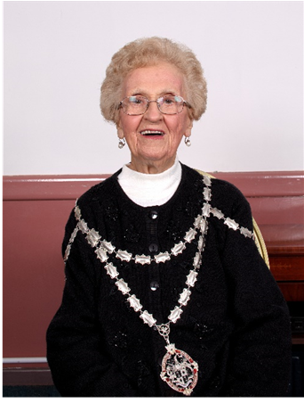
I am very pleased to be introducing our first ever Business Plan for Blaenavon Town Council for the period April 2018 – May 2021.
This document provides a summary of the main aspirations of Blaenavon Town Council (BTC) for the next four years. It will determine how your council will plan and achieve these objectives with review and input from the appropriate local organisations and key partners.
We hope that it will enable you to understand the Council’s aims, policies and governance arrangements and help inform as to what might be expected from the Town Council during that period.
Our Business Plan should also give you the confidence that your town is being supported in an efficient, forward thinking and effective way. However, the work of the Town Council is not limited by the aspirations and objectives of its Business Plan. We are always ready to consider new projects, take on new challenges and listen to your ideas.
The Council understands that community engagement and involvement is key to our success and therefore we would welcome your comments and suggestions as we move forward.

Introduction
What is a Town Council Business Plan?
It is a statement of the Town Council’s vision for the town, its purpose, values, objectives and key priorities.
It is not intended to be a traditional ‘Town Plan’ which sets out aims and ambitions that are delivered by the community and partners. Rather it is a document that sets out what Blaenavon Town Council itself can achieve, either directly or by trying to increase its influence on the relevant delivery body, such as the County Borough Council.
The aim of the Business Plan is to give Blaenavon’s residents a clear understanding of what the Town Council is trying to achieve and how it intends to deliver this. It details what the Town Council intends to focus on over the next four years. The Business plan will be used each year to plan activities and set the budget for the coming year.
Why has the Town Council decided to produce a Business Plan?
Having an agreed strategy will provide a framework for the Town Council to work within, enabling it to operate in a more consistent and co-ordinated way. Since the development of the Business plan has been based on community engagement and involvement, the Town Council will become more confident and proactive in its decision-making around service delivery.
The plan helps the council to minimise risks, it clearly justifies the budget and the Council's actions to all parties. It provides a benchmark for reviewing the Council's performance and shows that the Council has planned its activities with care. The plan provides a basis for additional decision making and it provides clear guidance to your Councillors, together with the Clerk / Responsible Financial Officer.
At the same time, the Business plan will help the local community to have a better understanding of what the Town Council does and, to clarify what it doesn’t do; in other words, to explain what issues fall under the responsibility of other delivery bodies such as Torfaen County Borough Council and other statutory organisations.
It is a ‘live’ document which the Town Council will update regularly, enabling it to track and monitor its progress against the key priorities. Because the Business plan will be publicly available, Blaenavon’s residents will also be able to monitor progress.
Community Involvement in the Business Plan process
To ensure that the Business plan truly represents Blaenavon’s best interests, the Town Council invited the local community to participate in its development.
In January 2018, a consultation document was made available to the residents and businesses in Blaenavon, completed responses were analysed, and covered a range of age groups.
By maximising the opportunities for community engagement, Blaenavon Town Council is well placed to support the key plans and objectives that will shape Blaenavon in future years.
Monitoring the Business Plan
Evaluating progress against the list of activities which make up the ‘Action Plan’ (Appendix 1) will take place at monthly Town Council Finance meetings.
Each meeting will consider one of the Business plan projects and will seek to understand the progress made, where further work is needed and if there are any blockages to progress. The whole Business plan will be reviewed annually to keep the document relevant and up-to-date.
The Business plan will be available on the Town Council website, with hard copies available to view in the Town Council Office, Library and Heritage Centre.
Our Business Plan will continue to be the main way of telling you what we are doing to meet the needs of the community. It’s a two-way conversation. Please tell us what you think about it. We welcome your comments.
If you require any further information that would help you understand what we are trying to achieve, please let us know. We can also provide additional information on the issues raised in the Plan.
It is our intention to review the Business Plan regularly, publish progress and make any changes considered necessary as a result.
Please contact:
Kevin Warren, Town Clerk, Blaenavon Town Council, 101, High Street Blaenavon, Torfaen, NP4 9PT
01495 790643 – blaenavontc@btconnect.com

The Town Council

An overview of Blaenavon Town Council
Blaenavon Town Council is a corporate body. It exists whether or not there are members. It is distinct from, although composed of its members namely Councillors.
Blaenavon Town Council is not a voluntary organisation, or a community group and it has no reference to the Church or any religious purposes. It is a local authority and the first tier of local government.
There are two tiers of local government, each with different responsibilities. Blaenavon Town Council is the first and most local tier, with an important role to play in promoting the town, representing its interests and supporting the work of different groups within the community.
Torfaen County Borough Council is the second tier and is responsible for services including car parking, street cleaning, highways relating to both roads and pavements, education, health and social services, public rights of way and libraries to name but a few.
The Town Council spends public money through funds raised from the council tax (known as the “precept”) and its members are elected to office.
Blaenavon Town Council has twelve Councillors who are elected every five years. The Town Mayor is elected annually at the Town Council Annual General Meeting held in May, together with the appointment of the Deputy Mayor.
Blaenavon Town has two wards namely East and West. Each ward has six councillors currently representing the Labour Party, Plaid Cymru, together with four independent councillors. Elections were last held in May 2017 and are scheduled to be held next in May 2021,
Councillors are unpaid and commit their time to improving Blaenavon and maintaining it as an attractive and sustainable place in which to live, visit and to do business.
The Town Council is extremely proud of the World Heritage status that Blaenavon holds and are committed in every way to promote and enhance this fantastic accolade. The Town Council works with and supports other local organisations. It also appoints councillors to sit on committees and outside agencies.
The full Council meets monthly (4th Wednesday) and the Finance Committee (2nd Wednesday) in the Council Chamber. All meetings are open to the public with a period set aside for members of the public to address the council with relevant questions.
Local councils are created by law (An Act of Parliament) namely the Local Government Act 1972. They can only do those things which the law permits them to do which are known as Powers. In addition, there are things stated in the law which local councils must do, known as Duties.
Duties
Duties placed upon the council are limited. Many of these duties are procedural and include that a Chairman or Mayor must be elected, that all meetings must be given public notice of at least three clear days, and not less than three meetings plus one annual meeting of the council must be held during a year.
There are some duties relating to functions and these include the fact that councils must consider the impact of crime and disorder within their decisions.
Powers
The powers a local council have are wide and varied. These are functions laid down in various Acts of Parliament which local councils are permitted to carry out if they so wish.
Some of the things a local council may do include the provision of (or contribution to) a wide range of recreational facilities, tourism schemes, festivals, fetes and the arts, bus shelters, litter bins, meeting and conference rooms and facilities, footpaths and street cleaning to name but a few.
Town and Community Councils vary in size, from representing tens of thousands of people down to less than 100 people but the laws which govern them are the same. The population of Blaenavon is 6,000 with an electorate of 4,510. The power to incur expenditure, not otherwise authorised, is given to the council by Section 137 of the Local Government Act 1972.
Role of the Local Council
Blaenavon Town Council represents the views, needs and wants of the community, acting as the cohesive voice. Councillors have a collective responsibility to listen and respond to constituents.
Blaenavon Town Council has a role as employer. This means that it is subject to all employment and equality laws.
Whilst Councillors have individual responsibility for the decision-making process, decisions are ratified by the whole Council. In other words, each Councillor has a 1/12th decision making and voting right. All ratified decisions are recorded within the Council meeting minutes and the Clerk is responsible for their implementation and providing future updates.
If the Council acts beyond its powers, it is said to act “Ultra Vires” this is the Latin meaning for “Beyond its Powers”
The Council is also subject to an annual internal and external audit and has a duty to appoint an Internal Auditor. There is also an obligation for the council to act with openness and transparency as well as abiding by both the Freedom of Information Act 2000, the Data Protection Act 1998, Employment / Pension regulations together with the Equality Act of 2010.
The role and responsibilities of a local council are often far above the impressions that members of the public envisage.
Town Council Staff and Management
The Council has one employee. The administration of the Town Council is carried out by a Town Clerk namely Kevin Warren who is appointed by the Council and is also the Council’s Responsible Financial Officer (RFO).
The Town Clerk must carry out all the functions required by law as the Town Council’s Proper Officer and issue all statutory notifications determined by legislation in particular the Local Government Act 1972.
There are many very effective, pro-active councils across the country with a trained, professional clerk and enthusiastic, skilled councillors. There is a need to be well-informed of many laws and responsibilities.
It would not be possible or necessary to know everything there is to know, but the provision of a training budget and the commitment to training for Clerks, and Councillors is vital to an efficient and effective council.
Blaenavon Town Council is a member of One Voice Wales who operate a training schedule for Community and Town Councils. They deliver training to Councillors (Clerks are also welcome) on a wide range of subjects which support objective decision making with up to date legislation.
Members of Blaenavon Town Council have attended numerous training courses since the newly elected council was formed in May 2017.
The Clerk of the council is also a member of the Society of Local Council Clerks which is the professional body for local council governance and administration across Wales and the United Kingdom.
Your Town Council is pictured below:
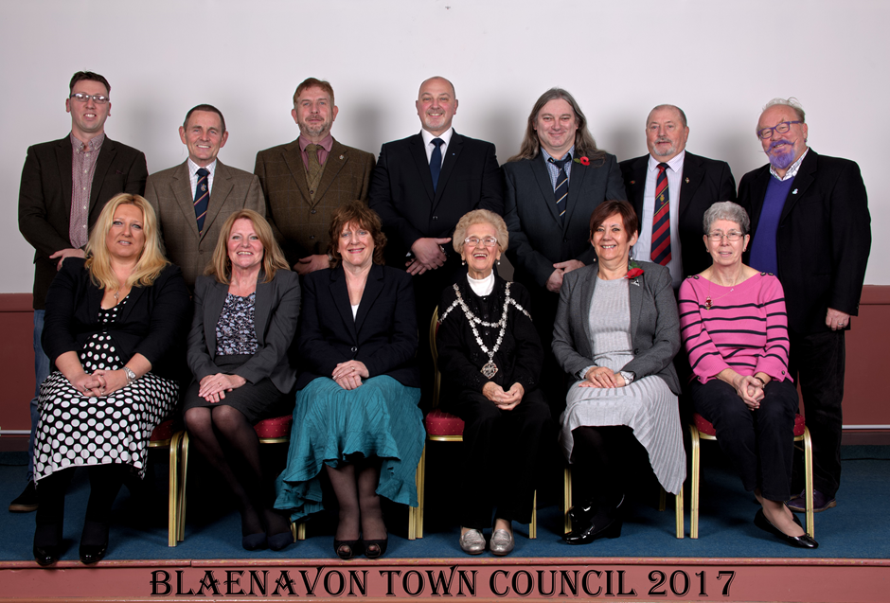
Corporate Vision and Objectives

The Town Council’s vision for Blaenavon is:
A successful, vibrant, attractive town, where people want to live, work, and visit.

The Town Council’s Mission Statement is:
To improve the quality of life for residents by ensuring that Blaenavon is a desirable, thriving and sustainable place in which to live, visit and do business.
Some examples of this are listed below:
- It provides a democratic and representational voice for the community.

- Where services are provided directly they are managed to a good quality standard, in an efficient, effective and responsive way, at an affordable cost.

- Where services are provided by others, the Town Council endeavours to ensure that they are dealt with effectively, and in accordance with the wishes of the community.

- It works with its residents, principle authorities and other service providers, businesses and community organisations with the aim of achieving a safe, healthy, prosperous and sustainable community.

Blaenavon Town Council is passionate about the community it serves and is always looking to support initiatives to enhance service delivery and wellbeing. An example of this is the work that is currently being conducted in relation to Dementia awareness.
The aim is to promote Blaenavon in becoming a Dementia Friendly Community. To achieve this, Councillors received training in September 2017 and are now accredited as Dementia friends. They have implemented an action plan to show how they are working towards delivering Dementia awareness within Blaenavon.
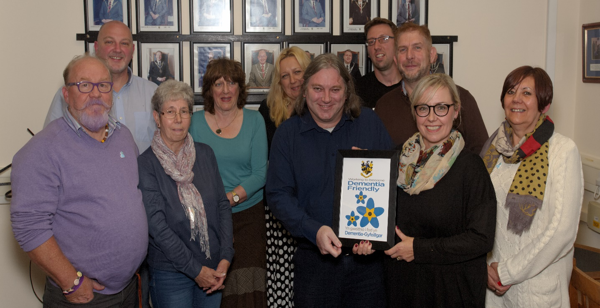
In December 2017 the Council set up an awareness input for all Blaenavon Town traders. This was held at the Queen Victoria pub aided by mince pies and a glass of wine.
In January and February 2018, the Council initiated and supported further awareness inputs to other organisations within the Town namely the Royal British Legion, the Workmen’s Hall and staff at the Museum.
The Council is also working with local partners at Big Pit and other regional organisations to support its ambition for Blaenavon to become the first Dementia Friendly Community in Wales.
The Key Objectives of Blaenavon Town Council are:

- To serve those who live, study and work in Blaenavon and those who visit the town.

- To promote and represent the community's views and aspirations at local, county and national level.

- To provide high standard, cost-effective services and amenities to help meet the needs and wishes of residents.

- To work in partnership, or otherwise, with other statutory and voluntary bodies, businesses and individuals to ensure and improving standard of services and facilities to meet the needs and expectations of Blaenavon’s residents.

- To achieve more influence over service delivery and development in the town to ensure that the best interests of Blaenavon are considered.

- To seek a fair share of investment in the town by local and regional authorities.

- To encourage the devolution of services to the Town Council where they can be delivered more effectively and efficiently, and ideally with no additional cost to the tax payer.

- To enhance and promote the historic and cultural heritage of Blaenavon and safeguard its unique identity and its natural and built environment recognised with World Heritage Status.

- To encourage and promote the economic and commercial vitality of the town centre and to strive for a pleasant, clean and safe environment throughout the town.

- To promote and support local voluntary groups and clubs that seek to assist residents and visitors to Blaenavon.

- To be a professional, competent and caring Town Council.

- To help to create a socially inclusive and caring community which embraces all its residents, irrespective of age, culture, income, race, sexual orientation, gender, disability or religion, and which seeks to develop their well-being, knowledge, understanding and cooperation.

Financial Information

The successful achievement of the Council’s objectives is dependent on the Council and its Clerk managing and delivering projects, processes, governance and activities to a high standard thus ensuring confidence in being well placed to achieve the objectives set out above.
The Council has highlighted the below seven processes as being crucially important:

- Developing the capability and capacity of councillors and staff.

- Liaising with and influencing other key partners and organisations.

- Long term in strategic planning.

- Knowledge management.

- Developing policies and procedures.

- Community engagement incorporating social media.

- Robust administrative and financial control methods.

Finance and General Purpose
Income
The Town Council is funded by the residents of Blaenavon, through what is known as the ‘precept’. This is the local tax set by the Town Council which is collected on its behalf by Torfaen County Borough Council as part of the Council Tax bill.
On average, £49.03 per year (Band D property) of Blaenavon residents’ Council Tax (i.e. £0.94 per week) contributes to the Town Council precept. As an example, the budgeted expenditure for the Council in 2018/19 is £93,744. This is funded from Blaenavon Council Tax Payers.

Expenditure
The main items of expenditure are:
- General Town Council administration and staff salary, office rent and service charges.
- Match funding Townscape Heritage Project.
- Community themed projects allocated with the Town Council Business Plan.
- Town Council Carol service / Christmas lighting and switch-on event
- Community organisation grants
- Town floral displays
- Town events / festivals
- Remembrance parade

Blaenavon Town Council contributes to the community in many ways. Recent examples for 2017 are:
- Blaenavon Townscape Heritage Fund £10,000

- Blaenavon Heritage Day £10,000

- Christmas Lights £15,000

- Town Carol Service £2,500

- Christmas Cracker Event £3,000

- Grant Aid £2,000

- Purchase Defibrillators £3,250

- Individual Donations to local organisations £1,000

- Flowers / Hanging baskets £1,000

- Workmen’s Hall improvements £7,500

- Support for Busy Bees Nursery £5,000

Total Contributions to date: £60,250

Except for a small contingency sum, the budget is fully allocated. Therefore, unless the Town Council can secure new grant funding which is only available for certain activities, any new activities or facilities which require additional resources would either have to replace an existing activity, be funded from reserves, or be funded via an increase in the precept.
Any un-used contingency or under spend can be allocated to a rolling capital fund and built up for specific purposes an example of which are earmarked community themed projects allocated within the Business plan.
Reserves
Blaenavon Town Council adopts a risk-based approach to its levels of reserves which is reviewed annually. Currently the minimum level of general reserves is set at approximately six months gross operating costs, within Wales Audit Office guidelines of 3-12 months costs. Reserves can only be held above this for specific, earmarked purposes as alluded to above in relation to Community themed projects.
Allowances
Councillors are unpaid but can claim an allowance for their duties which is currently £150. There is however an allowance given to the Mayor to meet any expenses involved in fulfilling the Mayoral duties. The agreed amount for 2018 /19 is £1,500. Deputy Mayor £500
During the Plan period, Blaenavon Town Council will:

- Continue to improve the budget setting and monitoring process and to identify efficiencies.

- Ensure that monthly income and expenditure reports are reviewed by the finance committee together with a quarterly review by appointed members and published online.

- Ensure accounting and audit procedures are completed in a timely manner.

- Review and maintain an up to date and effective Risk Management strategy at least annually.

- Review and maintain an up to date and effective Financial Regulations document at least annually.
Audits
Blaenavon Town Council submits its Annual Return to the External Auditor each year in accordance with the Accounts and Audit (Wales) Regulations 2014. These were made available for inspection in September 2017 by local electors and are published on our website.
A copy of the previous three year's annual return is also published online.
In addition to the annual external audit Blaenavon Town Council commissions a six monthly Internal audit. Quarterly inspections are also conducted by two appointed Councillors for added resilience and scrutiny.

Governance &
Accountability
Councillors/
Members
Responsible
financial
Officer
Internal
Audit
External
Audit
Clerk
Town Council Governance
Good Governance Objectives:
Blaenavon Town Council aims to be a professional, competent and a caring Town Council.
To be open and accountable in all that it does, whilst ensuring the management of Town Council resources are both rigorous and sound.
Blaenavon Town Council have in place their own Standing Orders and Financial Regulation schedules, both of which have been reviewed extensively and formally adopted by the Council in November 2017.
All matters in relation to finance and audits are completed whilst observing the Governance and Accountability in Local Councils in Wales – A Practitioners Guide 2011 (Amended 2014)
During the plan period, Blaenavon Town Council will:

- Be well-informed about the needs and opinions of the town’s residents, businesses and local organisations by consulting them on relevant issues.

- Improve services to the public by encouraging members and staff to develop their skills, by undertaking appropriate training.

- Ensure councillors are given the opportunity to keep abreast of new opportunities and policies.

- Be a responsible and fair employer by providing development opportunities and conditions for its staff.

- Continuously promote public participation in all town council meetings and initiatives.

- Deal with enquiries, complaints and fault reports from members of the public effectively and efficiently.

- Be an effective custodian of the council’s property, documents and all communications.

- Continue to review its policies and procedures to ensure that the council operates and delivers services in an open, transparent, legal and business-like manner.

Governance Activities:
To achieve the objectives detailed above, Blaenavon Town Council will:

- Carry out annual policy and governance reviews with any recommendations for changes to be agreed at the next annual or appropriate Town Council Meeting.

- Conduct a review of training needs of both Councillors, staff and monitor this annually.

- Invite representatives of outside agencies to address the Council on key matters of interest at Town Council Meetings.

- Conduct annual performance management reviews with the Clerk / Responsible Financial Officer

- Set up working groups with other statutory and voluntary bodies, businesses, residents and other stakeholders as appropriate to facilitate a coordinated effort.

- Appoint representatives to appropriate external agencies and committees as and when required to complement the council’s aims and objectives.

- Attend relevant conferences and meetings.

- Adopt a constitution to aid the control of its policies and regulations.

- Promote the highest standards of openness and transparency by ensuring that as much information as possible is available online, whilst protecting sensitive and confidential information through an effective Data Protection Policy.

Blaenavon Town Council’s main areas of responsibility
The Town Council has responsibility for:

- The provision of Christmas lighting.

- Blaenavon Town Carol Service.

- The provision of Town floral displays.

- The funding and delivery of town events (Heritage Day)

- The match funding of Blaenavon Townscape Project £30k until 2021

- The provision of Community Organisation Grants. (Grant Aid)

- The Mayoral Civic Service.

- Remembrance Day Parade.

- Civic Awards.

- Individual donations to local groups.

- Submitting comments on all planning applications and change of use applications in Blaenavon as a statutory consultee of TCBC Planning Authority (Brecon Beacons National Park Authority)

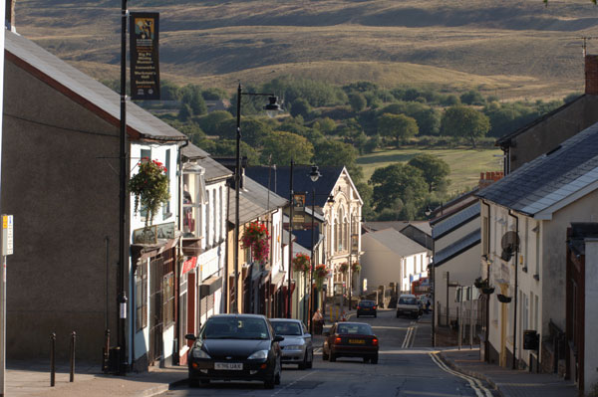
The Council is also represented on several external organisations, including:
- Blaenavon Town Team.

- Pontypool Museum Trust.

- World Heritage Committee.

- Torfaen Disabled Transport.

- Torfaen Association of Local Community Councils

- Appointment on local schools governing bodies.

- Workmen’s Hall Committee.

- Brecon Beacons National Park Committee

Who else has responsibility for service delivery in Blaenavon

- Torfaen County Borough Council is responsible for environmental services, litter, refuse and recycling, including dog fouling. It manages the majority of the town’s car parks, business support, on-street parking, highways issues, signage, lighting it is also responsible for health and social care, library services and education.

- The Borough Council own the Workingmen’s Hall and the Heritage Centre. The Town Council rents the Council building from Torfaen Borough Council

- Monmouthshire Diocese is responsible for the delivery of church services within the town together with other local chapels

- Brecon Beacons National Park is responsible for development control and strategic planning in terms of both business and housing development in Blaenavon. It also has a key role in terms of sustainable food and farming, biodiversity, climate change and tourism.

- Gwent Police together with the Police & Crime Commissioner is responsible for addressing crime and community safety in Blaenavon.

Where services are provided by others, the Town Council endeavours to ensure that they are dealt with effectively and in accordance with the wishes of the community.
The Mayor and Civic events
The Mayor of Blaenavon is elected at the Annual Council Meeting in May each year. At this time the new Mayor announces which charities they will be supporting during their mayoral year in office.
Every year the Mayor looks forward to a full year of fundraising activities and Mayoral engagements across Blaenavon and neighbouring towns.
The Mayor hosts a number of events during the year in office. The Town Council supports six regular events for the Mayor these are listed below.
The Council also supports the Mayor’s attendance at other events within of the Town together with other functions relating to neighbouring community and county borough councils.

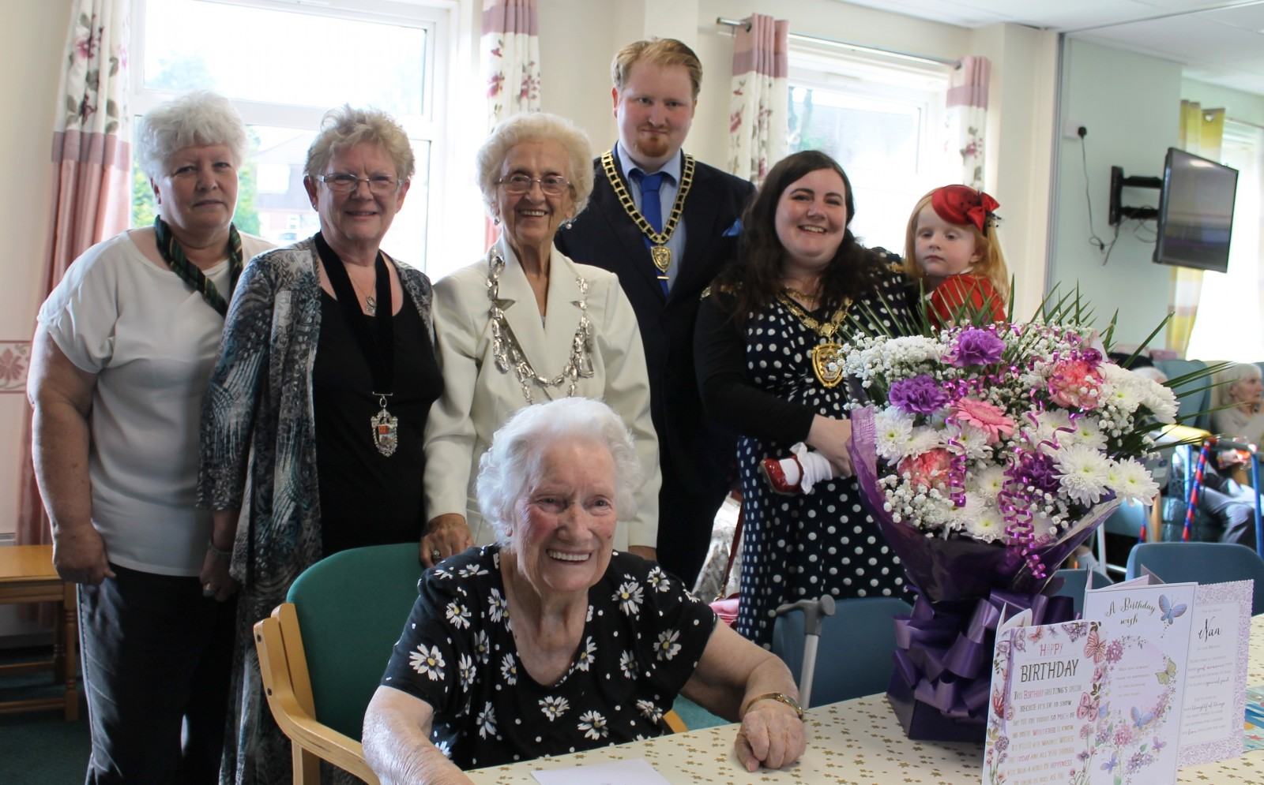
During the Plan period, Blaenavon Town Council will:

- Regularly review civic events to ensure their continued improvement and relevance.

- Support the community in celebration and commemoration of key local and national events.

- Promote the work of the office of the Mayor of Blaenavon

- Mayor’s Civic Reception

- Blaenavon Town Heritage Day

- Town Carol Service / Switching on Christmas Lights

- Grant Aid Evening

- Civic Awards Evening

- Remembrance Day Parade

Public Events
Most events and festivals held in Blaenavon are in partnership with local organisations namely Blaenavon Town Team, Big Pit mining museum, Blaenavon Heritage Centre, Torfaen County Borough Council and other smaller organisations for example Blaenavon Camera Club and the Royal British Legion.
The Town Council is seeking to support the development of community-based organisations, driven by key local stakeholders to promote public events and tourism.
The Town Council retains a small budget to fund community celebrations / festivals with smaller amounts of funding made available through occasional grants for those projects which are felt particularly beneficial to Blaenavon’s residents and the wellbeing of the community in general.

Heritage Day
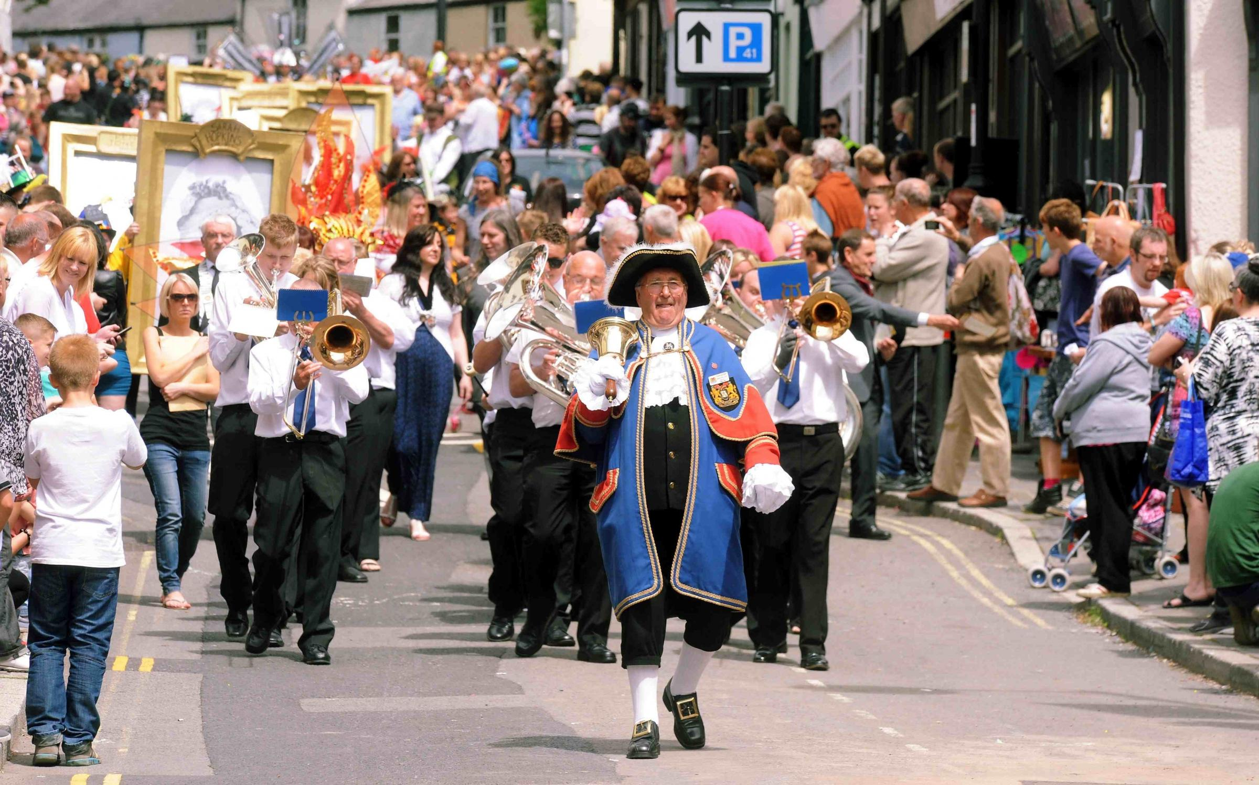

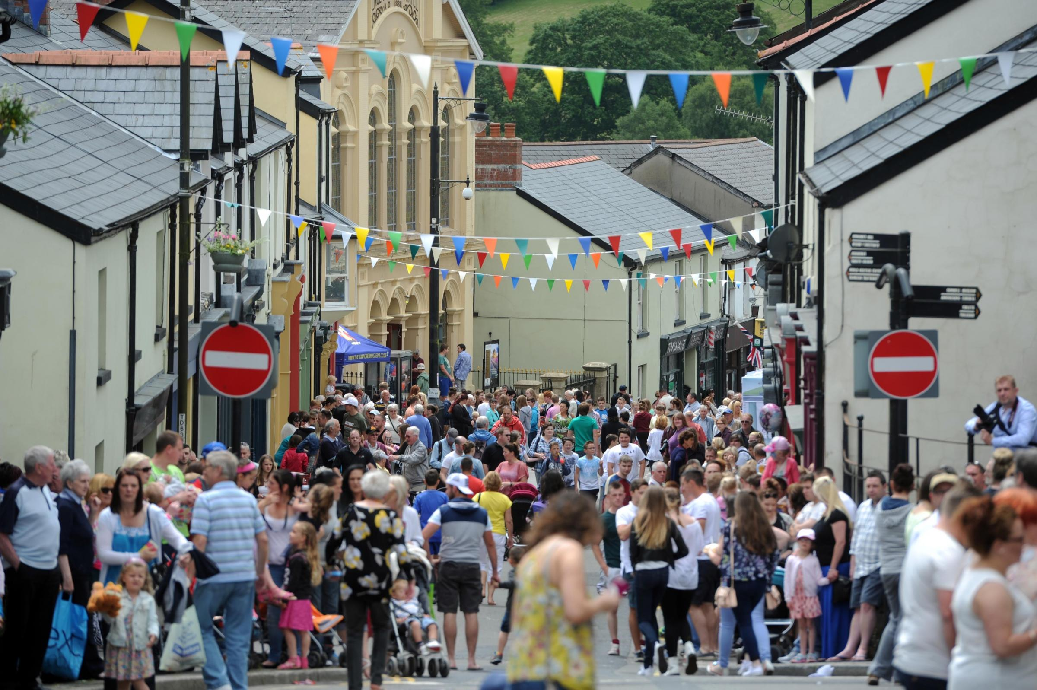
During the Plan period, Blaenavon Town Council will:

- Support the establishment of local initiatives for the delivery of safe and successful events and promote the town in line with the Wales Measure Act 2011 and The Wellbeing for Future Generations Act 2015

- Consider how best to fund and support community events.

- Host information about local clubs and societies on the Town Council website and other social media opportunities.

- Work with Torfaen County Borough Council and other local organisations / businesses to influence the improved scheduling of any externally run events and to encourage better management of identified problems / issues and the implementation of lessons learned.

- Promote key local events through the Town Council’s Social media and other avenues.

Town Carol Service and Christmas Lights
During the Plan period, Blaenavon Town Council will:

- Organise the installation of the Town’s Christmas lights with its partners at SSE street lighting.

- Organise the purchase and erection of the Town’s Christmas tree with TCBC.

- Organise the leasing and storage of the Town’s Christmas lights from its supplier at Festive Lighting Services

- Organise and work in partnership with Blaenavon Churches Working Together to deliver the Town Council’s carol service at Bethlehem Court.

- Work in partnership with traffic management department at TCBC to organise road closure orders

- Work in partnership with Gwent Police to supply resources for the Town Council Carol service to support community safety.

- Work in partnership with Blaenavon Town band, Blaenavon Male Voice Choir and others to deliver the Town Council’s carol service at Bethlehem Chapel.

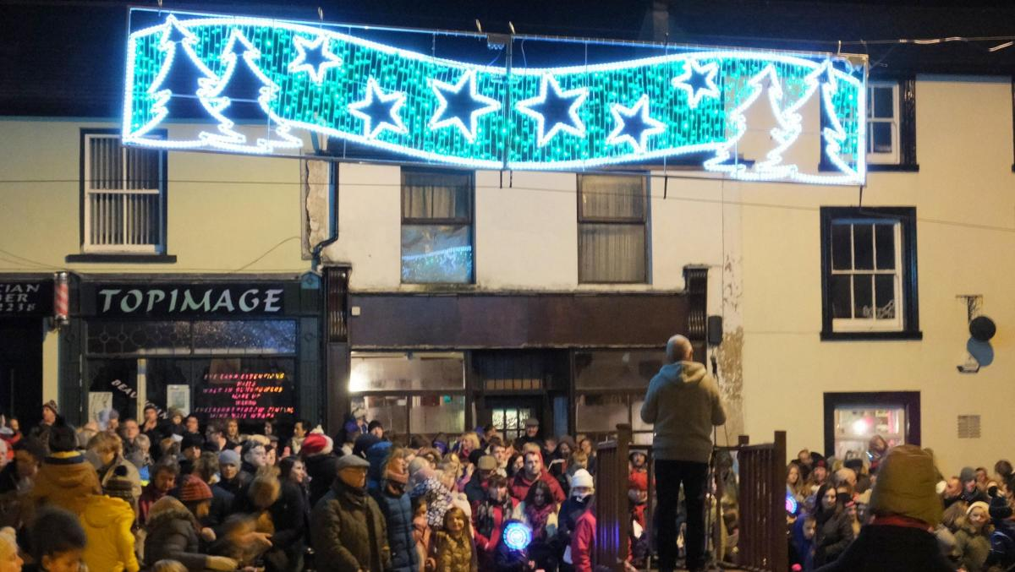

Occasional Donations and Annual Grants
Blaenavon Town Council is committed to supporting and strengthening the many networks and community groups that help to make a positive difference to Blaenavon as a place to live, work and visit, for everyone.
We know that the Council can make a difference through our grants process, but it is also important that we seek a relationship with many of these groups to explore other ways in which they can develop and grow as they need to.
For the financial year 2018/19 a total of £5,000 was made available to support community organisations who can demonstrate a clear need for financial support whilst contributing towards the vision and aims for Blaenavon.
Projects and activities must have a specific benefit to residents of Blaenavon. Occasional donation requests are considered at each full council meeting.
In addition, the Town Council provides regular annual support to several other local organisations for example Blaenavon Town Team, Big Pit mining museum and the Blaenavon branch of The Royal British Legion.
An excellent example of how the Council support local organisations is the donation of £3,000 to Blaenavon Town Team who organised and delivered the successful Christmas Cracker event in December 2017, also Blaenavon Camera Club who organised a photographic exhibition at the Heritage Centre in November 2017.
Another extremely beneficial donation provided by the Town Council was the financial support of £600 given to local foodbanks in the lead up to Christmas 2017.

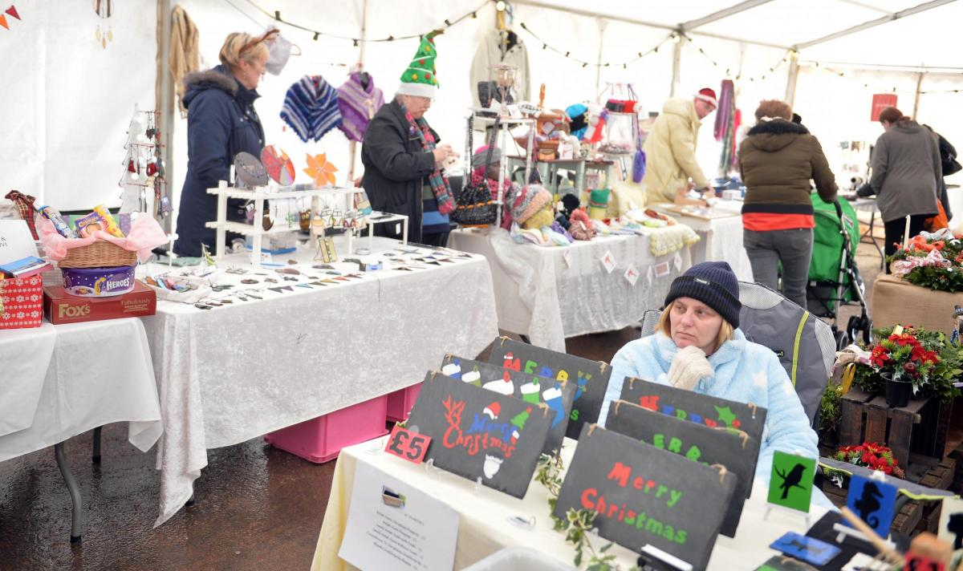

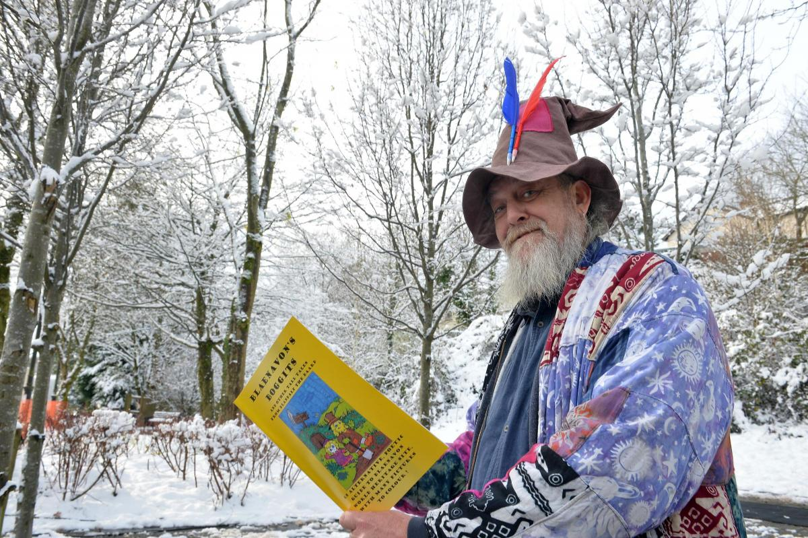

Blaenavon Town Council will endeavour to support local non-profit organisations through its grants scheme. It will take actions to increase the impact of the grants by:
- Regularly reviewing grant policy in terms of assessing the likely impact of the grant.

- Increasing active promotion of the occasional donation requests on the Town Council website, social media and in the press.

- Request feedback from successful grant applicants to evaluate the success of their projects together with attendance at Council meeting to provide verbal updates.

Communications
Blaenavon Town Council recognises the benefits of regular and effective communication in building positive relationships with residents, local organisations, businesses and key partners.
It has recently set up a Facebook account together with a newly built Website to support the council’s on-going commitment in terms of community engagement whilst highlighting the positive work of the Town Council.

During the plan period, Blaenavon Town Council will:

- Continue to develop the website providing information about the Town Council and signposting people to other service providers.

- Post regular news regarding Town Council initiatives on the website, and via social media and the press.

- Review and improve other methods of distribution for Town Council information and news.

- Provide an opportunity at each Town Council meeting for the attendance of the press and public to ask questions and receive relevant updates.

- Provide updated versions of the Town Council Business plan on the Town Council website and the provision of hard copies where required.

- The compilation of an annual report covering Town Council activities during the previous twelve months at the annual general meeting. (AGM)

- Continue to review the Council’s information and communication requirements.

- Review and upgrade as necessary the Town Council’s telecommunications and WI-FI systems to provide effective communication facilities in line with security measures.

- Regularly update the Council noticeboards with relevant and current information.

Remembrance

Blaenavon Town Council together with the Blaenavon branch of the Royal British Legion (RBL) organises the annual Remembrance service for the town.

This involves a parade through Blaenavon Town commencing at Broad Street car park and concluding at the Town’s war memorial at Church Road and High Street. A wreath laying ceremony is then conducted together with the observation of a two-minute silence at 11am. A service is then held at St Peter’s Church.
The event is extremely well supported by local organisations namely Blaenavon Town Band, local churches / chapels, the clergy, local businesses, youth organisations such as the Scouts and Brownies, local sports clubs and schools, together with the attendance of civic dignitaries from across the County Borough.

Importantly the event is extremely well supported by the Town’s residents who are rightly proud of the Remembrance Day event. In 2017 there were 84 wreaths laid at the cenotaph.

The Town Council also supports the RBL at events throughout the year, examples being the Passchendaele Remembrance Day in July 2017 together with the Remembrance Day concert held at the Workingmen’s Hall on the 11th November 2017.

In 2018 the Town Council will be involved and supporting the RBL in the 100-year celebrations marking the end of The Great War 2014 – 2018 and the sacrifices given by Blaenavon servicemen who never returned to the Town.

Blaenavon Remembrance Day Parade

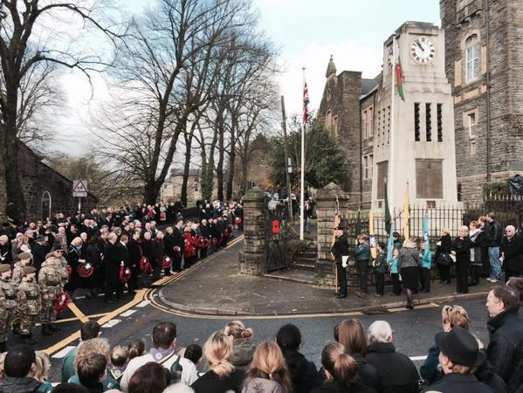

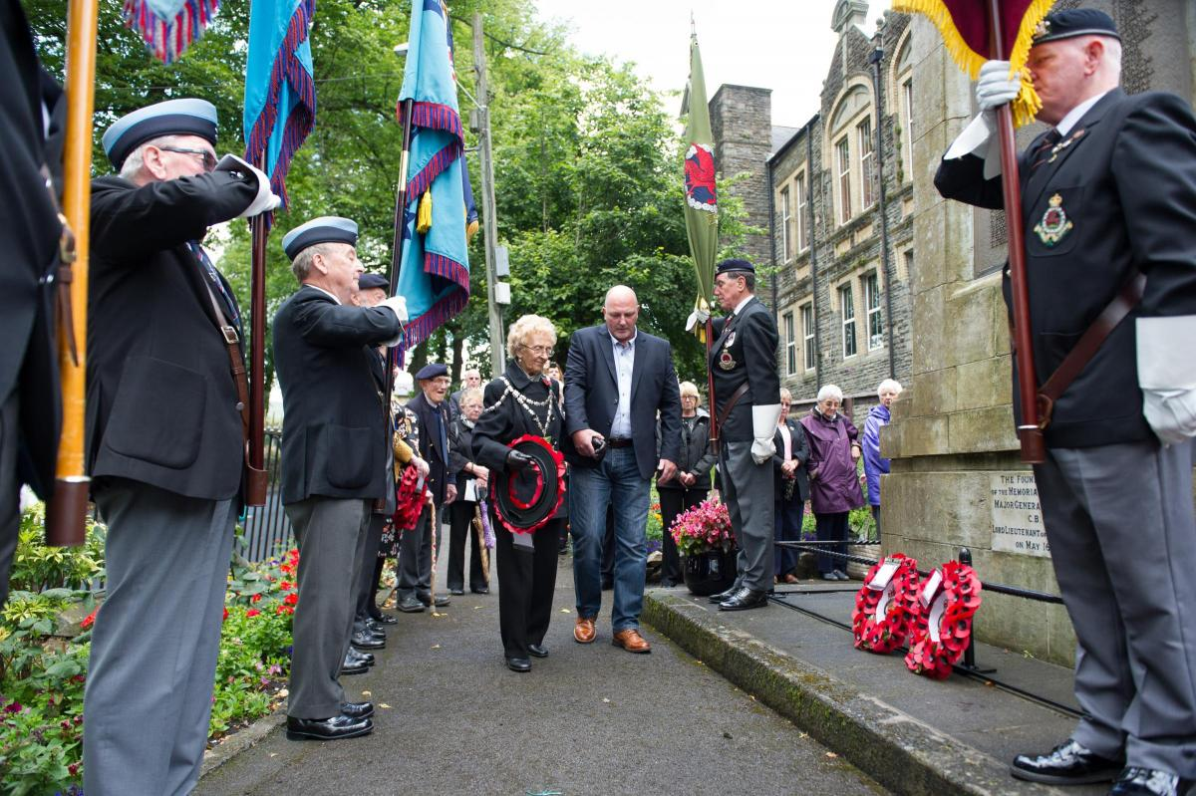

During the plan period, Blaenavon Town Council will:

- Continue to work with and support the Royal British Legion, local clergy and all local organisations to oversee the smooth running and organisation of the Remembrance Day Service.

- Publicise the event on the website, the press and social media.

Community Policing and Safety

Blaenavon Town Council works closely with Gwent Police and Torfaen County Borough Council on matters relating to Community Safety.

Councillors regularly engage with the Neighbourhood Policing Team and officers from TCBC community safety department. The Town Council building is often used for meetings with the Police, partner organisations and residents to discuss matters of concern and solutions to local issues.

Community Action days have recently been introduced where the police and partner agencies work with the community to highlight and deal with matters of concern.

Neighbourhood Policing Teams keep residents updated on progress related to priorities in the local area. They do this in many ways, including regular updates on their local website pages.
Blaenavon Town Council will continue to work in partnership with Gwent Police and other organisations so that they are able to deliver a service that is visible, accessible and responsive to what local people need.
During the plan period, Blaenavon Town Council will:

- Listen to residents and report their concerns to the relevant authorities.

- Work with the Police and other TCBC community safety officers to address the issues that have been identified and provide reassurance when required.

- Keep residents informed of progress made and signpost them to the relevant authorities.

- Continue to work with Gwent Police to share information on local crime and safety issues. This includes Gwent Police being invited to attend Town Council meetings and the Town Council forwarding any enquiries and concerns submitted to them.

- Facilitate access to the Police, by including Police contact information on the Town Council’s website and other social media

- Hold the Police and Crime Commissioner for Gwent together with the Geographical Policing Inspector to account by reviewing and responding to local policing strategies on behalf of residents.
Planning & Environment
Blaenavon Town Council is a statutory consultee for any planning applications submitted within the Town boundary or within the wider area which may influence the town or its residents.
Torfaen County Borough Council is the local planning authority and makes the final decision. Blaenavon also sits within the Brecon Beacons National Park and as such is regularly consulted in relation to planning matters.
Planning applications that are to be considered by the Town Council are forwarded to the Clerk by the local planning authority and these are brought to the attention of the full council monthly and are shown in the agendas document.
All applications which the council considers are recorded in the corresponding minutes for that meeting and any observations or concerns are brought to the attention of the local planning authority by the Clerk.
If members of the public are interested in a planning application, they are able to view this on the TCBC planning application website. They can attend a meeting to find out how the Town Council considered the application or enquire directly at the Town Council offices. The minutes of the meeting are also available on the Council’s website.

During the plan period, Blaenavon Town Council will:

- Encourage residents to participate in any strategic planning consultations which impact upon Blaenavon.

- Continue to comment on all key strategic planning documents and consultations that affect Blaenavon, ensuring that the Council’s knowledge and understanding of the local context is considered in planning decisions.

- Review the way in which it currently considers and supports planning applications, ensuring that its recommendations are robust, clear and represents the interests of the community wherever possible.

- Continue to establish a close working relationship with Torfaen County Borough Council, the officers and members on the planning committee, to ensure that the needs and best interests of Blaenavon are considered in planning decisions.

- Ensure that the Town Council’s views are appropriately represented at the Borough Council’s Planning Committee.

- Consider options for proactively targeting specific new businesses which meet the needs of residents and support the economic sustainability of Blaenavon

- Make recommendations to the Borough Council as to the use of receipts from the Community Infrastructure Levy (CIL) to enhance infrastructure facilities within the Town.

- Carefully consider applications for the work to protect trees, open spaces and buildings within the Town’s Conservation area.

Personnel
Blaenavon Town Council at present has one employee namely the Clerk / Responsible Financial officer. The line management structure for the Clerk is the Mayor and in their absence the Deputy Mayor.
There is an annual performance management review conducted in March each year. This is complemented by quarterly finance inspections which support the broader performance management process namely governance and accountability.
Blaenavon Town Council sets out to reward the commitment of its staff by providing a satisfying and flexible working environment in which its staff can develop. An example of this is the attendance at training courses delivered by SLCC, together with other regional events and conferences attributable to the role.
The Clerk is also a member of The Society of Local Council Clerks (SLCC) which the council supports. The Council is currently supporting the Clerk in achieving professional qualifications namely the Certificate in Local Council Administration (CiLCA) The Clerk has a contract of employment and Job description which is reviewed annually.

During the plan period, Blaenavon Town Council will:

- Review the staffing structure and budget on an annual basis, making recommendations where required’

- Oversee the management of Health & Safety and the Council’s corporate responsibilities as an employer.

- Conduct an annual appraisal of the Town Clerk

- Review and approve personnel-related policies and procedures.

- Ensure compliance with personnel related statutory requirements and legislation.

- Act as the first stage in grievance or disciplinary hearings.

- Develop staff through appraisals and approved training programmes

Highways
The Town Council is not directly responsible for the delivery of highways, transport, access or parking services in the town, but strives to ensure that the relevant delivery bodies provide a good quality, affordable service and considers the needs and expectations of its residents together with the town’s businesses.
This includes road and pavement repairs, traffic flow, winter gritting and local considerations for scheduling of major road works.
The Town Clerk and Councillors regularly engage with the Highways and Traffic management officers at Torfaen County Borough Council.
When required, attendance at Council meetings takes place in order that the council be updated on matters relating to highways for example road works and traffic calming measures. The Council is also instrumental in the consultation processes.
Another area where the Town Council is involved in highway matters is the many Road Closure orders that are negotiated and financed for events such as Heritage Day, Remembrance Day parade and the Town carol service.

During the plan period, Blaenavon Town Council will:

- Work with Torfaen County Borough Council (TCBC) on a long-term plan for road and pavement repairs in the town, including effective maintenance of roadside verges and where appropriate well-maintained signage.

- Continue to collate and forward reports of dangerous kerbs or pavements to TCBC.

- Liaise with TCBC to influence scheduling of major road works so that, as far as possible, disruption to residents is minimised and peak visitor periods are avoided.

- Provide clear information on the Town Council website to provide guidance on how to refer highways matters.

- Work with TCBC to supply and maintain an adequate number of winter gritting bins and advise on appropriate locations.

- Liaise with TCBC to introduce road and pedestrian safety schemes linked to fact based risk analysis.

- Identify areas where improvements regarding street lighting is necessary and liaise with TCBC to provide this, also to look at the energy efficiency measures for existing street lighting and consider alternatives.
Street Cleanliness
Blaenavon Town Council strives to ensure the town retains a pleasant, clean and safe environment to support its World Heritage Status.
While the Town Council itself is not directly responsible for delivery of environmental services, it works in partnership with the relevant delivery bodies to encourage a high standard of services that meets the needs and expectations of its residents, businesses and visitors to the town. Torfaen County Borough Council is responsible for street cleaning in Blaenavon.
Blaenavon Town Team regularly conduct litter picks within the town. This is supported by Blaenavon Town Council who regularly assist.
During the plan period, Blaenavon Town Council will:

- Liaise with Torfaen County Borough Council to improve the quality of the service provided.

- Listen and respond to matters arising from residents and businesses in relation to street cleanliness and faulty litter bins.

- Signpost residents and businesses via the Council website on how to refer issues to TCBC
Public footpaths and rights of way

There are many public rights of way within Blaenavon and the surrounding countryside. Primary examples are the Garn Lakes and the Keepers pond areas to name but a few.

Blaenavon Town Council is not directly responsible for public footpaths but regularly consult with and promote the views of the community to Torfaen County Borough Council, Brecon Beacons National Park, Countryside Wales and Blaenavon World Heritage Environmental Group (BWHEG) in relation to these areas of natural beauty.

A recent piece of work that the Council has been involved in certainly in terms of consultation was the introduction of enforcement for dog fouling within these areas and the relevant signage that needed to be adopted. This was led by Councillor Alan Jones who is also the Cabinet Lead for Heritage, Culture and Tourism at Torfaen County Borough Council.

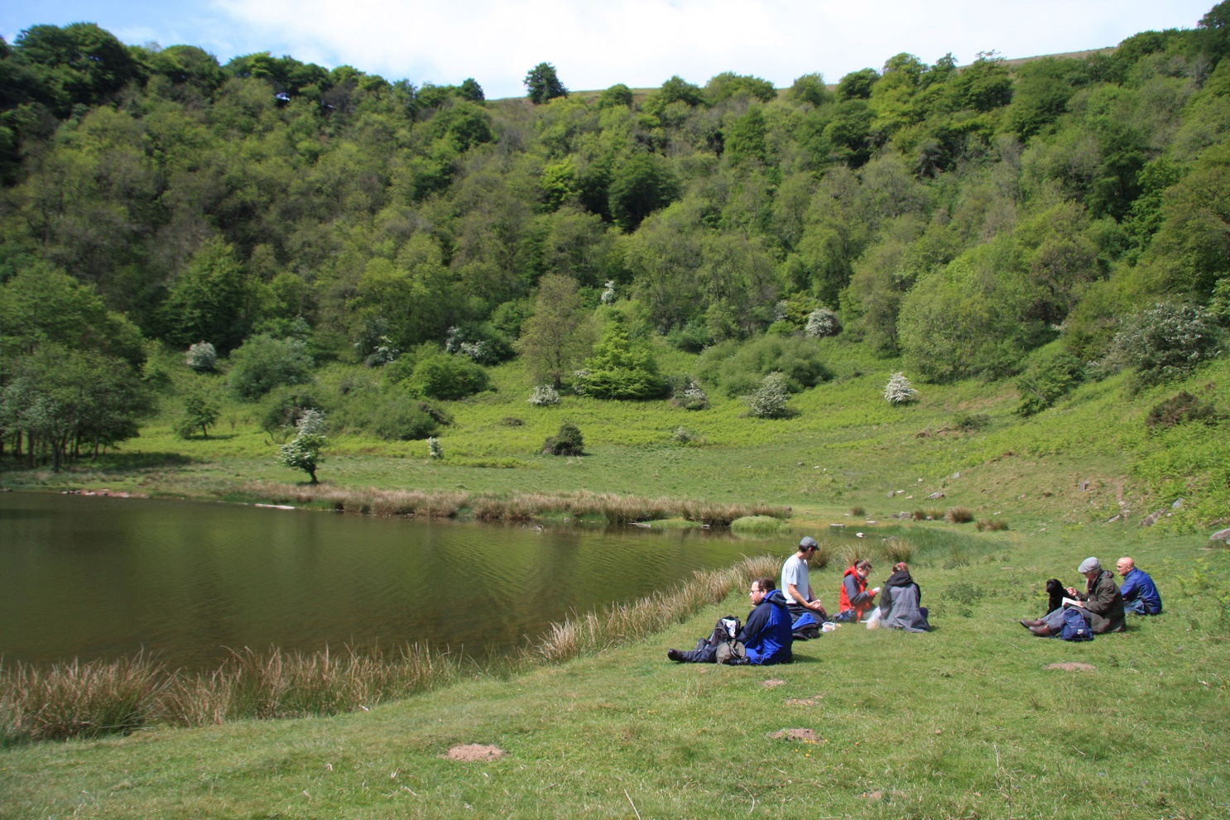

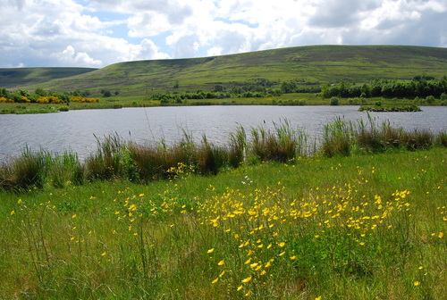
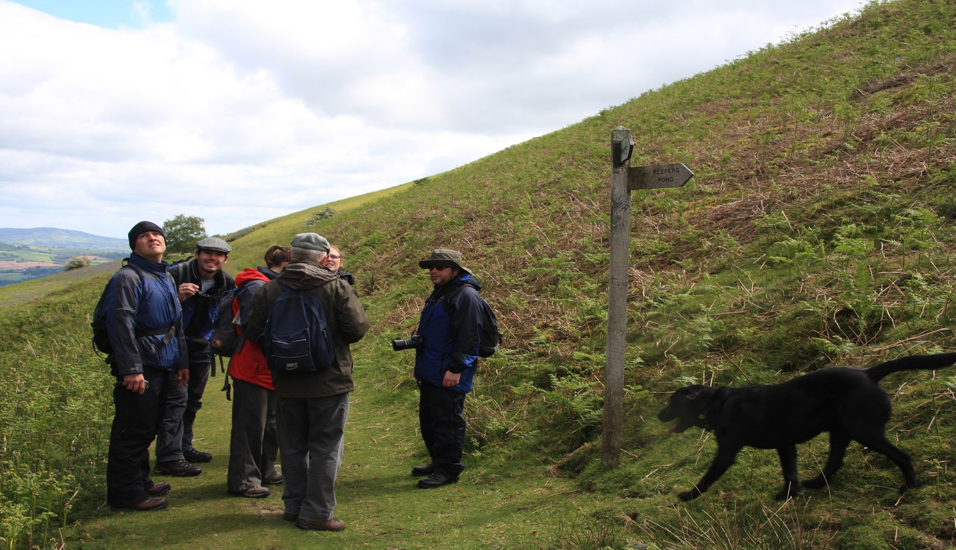

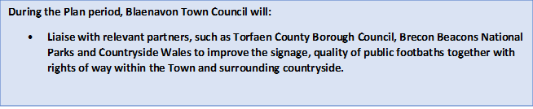
Economy and Development
Blaenavon Town Council encourages and promotes the social, economic, environmental and commercial vitality of the town. This will support its future prosperity, sustainability and enhance the cultural wellbeing of its residents and local businesses.
Although the Town Council’s own funds are limited it works in partnership with appropriate agencies and organisations to encourage and facilitate all opportunities.
The Town Council is a key partner in the Blaenavon Townscape Heritage Project, working with Torfaen County Borough Council and Cadw in securing National Lottery funding to develop the Town’s infrastructure and economic sustainability.
Blaenavon Town Council has budgeted for and committed £30,000 over the next three years to drive this project forward ensuring that future prosperity and economic growth is realised.
Blaenavon Town Council’s Economic Development Objectives
In terms of economic development and planning, the Town Council is guided in its activities and decisions not only by its corporate objectives (listed on page 8) but also by the following specific economic development objectives:

- To support a balanced approach to economic growth, ensuring the sustainability of the town and working with key partners to achieve this outcome.

- To support the development of tourism, recognising that this is one of the main drivers of the local economy, while at the same time encouraging wider economic development which safeguards the sustainability of Blaenavon as a World Heritage Town.

- To encourage a vibrant retail mix and to do what it can to encourage and support new businesses which meet the needs of Blaenavon’s residents and the wider community in general.

- To support the provision of good quality, well-managed events and festivals in the town, with its own financial support focused on community celebrations which enhance the wellbeing of its residents.

- To support the growth of the ‘Town Team’ or Business Improvement District (BID) for Blaenavon, to facilitate coordination of town centre initiatives working in partnership with Torfaen Council, Blaenavon Heritage committee and other relevant partners.

- To support the development of commerce and light industry for enhanced employment opportunities in the town, with the focus being on training, education and youth development.

- To promote and support entertainment and the arts.

Next Steps
The key milestones for achieving the objectives of this Business Plan from 2018-21 are set out in the action plan in Appendix 1 below.
Blaenavon Town Council will ensure that the goals and actions set out are delivered and properly resourced as the action plan progresses.
The Town Council has adopted a performance management approach, and will review progress against the Business plan regularly at its Finance meetings.
The Town Council is keen to consider new opportunities at any time and as such, the Business plan should not be a limit to the Council’s endeavours over the next four years.
In May 2021, as Council enters the final year of this plan, local elections are due to be held.
The new Council will continue to engage with the community and its partners and comprehensively review its objectives during the 2021-22 municipal year to both evaluate the success of this first plan and draft the next five-year Business Plan for the period May 2021 - May 2026.

Signed by Chairman: Date:

Signed by Clerk: Date:

Blank Page

Blaenavon Town Council
Project Action Plan 2018-2021
Appendix 1

APPENDIX 1 – ACTION PLAN 2018 -19

Reference | Project | Lead Organisation | Activity | Timescale and Review Date | Budget Required  Allocated Y - N | Outcome  Completed Y - N
BTC 1  May 2018 | Installation of 70 seats within the Workmen’s Hall Cinema | Blaenavon Town Council.  Blaenavon Workmen’s Hall PLC  Cllr Gareth Davies | The refurbishment of the cinema seats to support wellbeing and tourism within the Town. | 3 months | £10,000 | September 2018
BTC 2  April 2018 | Intergenerational Community Project | Blaenavon Town Council  Big Pit Mining Museum  Cllr Alan Jones | Deeper engagement activity linked to the dementia supportive community status for Blaenavon. | 12 months with quarterly review dates  Quarterly review delivered to Council July 2018 | £2,000 | In progress
BTC 3  April 2018 | Installation of new bunting within Broad Street Blaenavon | Blaenavon Town Council.  Cllr Nick Horler | The refurbishment of bunting within Broad Street Blaenavon | 2 months | £350 | Completed
BTC 4  May 2018 | Installation of World War 1 Benches at Cenotaph and Council offices | Blaenavon Town Council  Cllr Alan Jones | To commemorate the end of World War 1 | 2 months | £2,500 | Completed
BTC 5  June 2018 | Community Swim Project and Play Service Provision | Blaenavon Town Council  Torfaen Play Scheme  Cllr Janet Jones & Stuart Evans | To support Torfaen, Play Service in the provision of free swimming for the children attending the Play Service facilities during the school holidays | 2 months  Update September 2018 | £480 | Completed
BTC 6  July 2018 | Installation of Flowers and pots at Cwmavon Roundabout | Blaenavon Town Council  Cllr Janet Jones & Stuart Evans | To enhance the location whilst entering Blaenavon Town | 1 Month | £250 | Completed

Reference | Objective | Lead Organisation | Activity | Timescale and Review Date | Budget Required  Allocated Y - N | Comments  Completed Y - N
BTC 7  July 2018 | Installation of Information Boards at The Lion Hotel and Caddick’s Builders Blaenavon. | Blaenavon Town Council | The promotion of Blaenavon Town’s historic heritage and events, | 3 Months  Update September 2018 | £2000 | Progressing
BTC 8  July 2018 | Best Kept Premises Award  Blaenavon Town | Blaenavon Town Council  Cllr Denley - Jones | The promotion of Blaenavon Town’s appearance | 3 Months  Update October 2018 | £200 | Completed
BTC 9
BTC 10
BTC 11
BTC 12
Total to Date = £17,780

Reference | Objective | Lead Organisation | Activity | Timescale | Budget Required | Comments  Completed Y - N

Reference | Objective | Lead Organisation | Activity | Timescale | Budget Required | Comments  Completed Y - N

